

EMODnet Thematic Lot n° 7

EMODnet Phase III
-Task report (draft) -

EU-MUD
“European Marine Use Dataset from EMODnet-Human activities layers”

Y. Sagarminaga1, O. Solaun1

1. AZTI, Marine Research Division.
Herrera Kaia - Portualdea z/g. E-20110 Pasaia – GIPUZKOA (Spain)
ysagarminaga@azti.es

Date: 14/03/2025
Index

Executive summary 4
1. Background. 5
2. Objective. 6
3. The INSPIRE Land Use Theme 6
4. The MSP INSPIRE data model 15
5. Alignment and applicability of the EMODnet's Human activities to the "Land Use" and MSP application schemas. 18
6. Harmonisation of EMODNET's human activities datasets and generation of INSPIRE Land Use compliant GML files 22
7. Recommendations and conclusions. 26
a. EMODnet's datasets. 26
b. INSPIRE Land Use application schemas 28
ANNEX A. Field mapping analysis 32
A. Aggregate Extraction 32
B. Dredging 35
C. Dredge spoil dumping 36
D. Dumping munitions 36
E. Ports 37
F. Pipelines 38
G. Cables 39
H. Wind Farms 41
I. Ocean energy test sites 41
J. Ocean energy Project locations 43
K. Boreholes (Fossil Fuel Based Energy Production) 44
L. Active licenses (Fossil Fuel Based Energy Production) 44
M. Offshore installations (Fossil Fuel Based Energy Production) 45
N. Nuclear (Nuclear Energy Production) 46
O. Finfish production (aquaculture& fishing) 47
P. Shellfish production (aquaculture& fishing) 48
Q. Macroalgae (aquaculture& fishing) 49
R. Microalgae (aquaculture& fishing) 50
S. Bathing waters (Environment) 51
T. Lighthouses (Cultural heritage) 52
U. UWWTD Treatment Plants (Waste disposal) 53
V. UWWTD Discharge points (Waste disposal) 54
ANNEX B. Steps to apply INSPIRE schemas in GEOSERVER. 55
ANNEX C. Mapping xml file to be used in Geoserver. 58
ANNEX D. ETF Validation report. 60

Executive summary

This report describes the methodology used to generate the European Marine Use dataset (EU-MUD) product. This product is the result of harmonising the different EMODnet spatial datasets on human activities (or “uses”) in the marine domain into a single data model, adapted from the INSPIRE "Sampled Land Use" scheme.
EU-MUD exclusively includes EMODnet datasets providing information on human activities locations and characteristics including statistics. It excludes administrative or regulatory boundaries.
The generation of EU-MUD is an automatic and remote process, as it ingests data layers from EMODnet's Web Feature Service and harmonise them with a developed R-script.
The EU-MUD product (v1.0) is released in geopackage format file(s) including three tables:: i) the GEOM table including the spatial features (points, lines and polygons), ii) the OBS table containing all the activity attributes associated with the different geometries contained in the GEOM table, and a iii) SRC table containing the information on the various sources from which the data have been collected. Il also includes a classification of features using controlled classification vocabularies like the HILUCS_extended vocabulary or the EUROSTAT’s NACE 2.1. These controlled terms are used to define a EUMUD style SLD file embebded in the geopackage. In addition the metadata URLs of the original EMODnet layers, are included in the description field of each layer to maintain traceability with original EMODnet layers.
The EU-MUD product aims to facilitate the visualization and integrative analysis of marine use information in the context of multi-thematic studies (i.e interlinks between human uses and environmental components, marine use conflicts, risks, etc). In addition, this work will contribute to the further implementation of the INSPIRE data specifications and interoperability principles.

Background.

The analysis presented in this report is a follow-on of the works "EMODNET human activities data models: towards compliance with INSPIRE DATA Specifications.", published in February 2018 and available in (https://webgate.ec.europa.eu/maritimeforum/en/node/4147) and the “Implementation of the INSPIRE Land Use Theme for EMODnet Human activities datasets” in 2020.
The main conclusions of these works showed that although most EMODnet human activities datasets could be thematically related to existing INSPIRE application schemas, the alignments were more or less direct depending on the dataset analysed. Moreover, several datasets could be aligned to more than one INSPIRE application schema. Furthermore, it was found that similar information concepts (i.e. date information, dimensioning attributes, etc.) were treated differently across the different INSPIRE models.
Given these results, the harmonising the 66 EMODnet human activities datasets available at that time using these different application schemas would be conceptually and technically complex, and the result would probably not meet the interoperability objectives sought by INSPIRE.
An alternative strategy was proposed by the "MSP INSPIRE data model", developed in the framework of the Macaronesian Maritime Spatial Planning (MarSP). Their proposal consisted in using a single model to represent the different human activities in the maritime plans. This model called "MSP INSPIRE data model" was adapted from the "INSPIRE Planned Land Use" application schema under the INSPIRE "Land Use" theme.
The test of this approach resulted in a single dataset with a common structure that revealed several advantages to be used in studies needing information from different marine sectors and topics. However, it was not possible to fully include the EMODNET data layers information within the INSPIRE "Sampled Land Use" model framework, and several suggestions for improvements were made to make this single EMODnet human activities dataset more coherent, comprehensive, and useful, aligning as much as possible with INSPIRE codes and elements.
After considering these recommendations, a decision was made to try to design a simple and flexible model adapted from the INSPIRE "Sampled Land Use”, and enabling the accommodation of the heterogeneous information included in the EMODnet human activities datasets.

- Objective.

The present study aims to generate the European Marine Use Dataset (EU-MUD) product through the design and implement a single data model for all EMODnet human activities datasets, and develop a computer programme to remotedly retrieve the WFS EMODnet layers, harmonise them and create the EUMUD geopackage file.

- Data and methods.
  - Selection of datasets.
The Human Activities datasets from EMODnet to be included in EU-MUD, involve those providing information on the location (footprint) and characteristics of different human activities in marine areas under European jurisdiction. These datasets are retrieved from the EMODnet Human Activities Web Feature Server (https://ows.emodnet-humanactivities.eu/wms?VERSION=1.1.1) in their default geographic projection (EPSG:4326).
The datasets representing administrative or regulatory boundaries (i.e. Marine Protected Areas, Advisory councils’ boundaries, etc.) are not considered, as they do not provide information on actual undergoing activities. A mixed case is represented by datasets including statistical information by pre-defined statistical spatial units. In some cases, these spatial statistical references are closely linked to the footprint of the activity represented (i.e. waste and goods/vessels and passengers per ports), or fish effort in squares of 5x5 km. But in other cases (i.e. Fishery catches per FAO/ICES areas) the statistical spatial units are too broad to reflect the real footprints of the information provided. Even though, these datasets have been retained in the first version of EU-MUD.
Furthermore, some datasets have been excluded due to the redundancy and/or overlapping of the information they contain, with other datasets with higher spatial resolution. For instance, catches and effort data for “FAO major areas” have not been included as these are already covered at a more disaggregated level in FAO divisions, subdivisions and subunit areas. Additionally, the “port locations” dataset has been excluded as it only contains the location information that is implicitly included in the port statistics datasets.
The list of the retained datasets can be consulted in ANNEX I, while the list of excluded datasets, along with the rationale behind their exclusion, can be found in ANNEX II.

  - Data Model
The data model, used in this exercise, hereafter named “Marine Use Data model” or MUD model has been designed considering the following requirements:
- Comply as far as possible with to the INSPIRE 'Sampled Land Use' structure, field names and code lists.
- Integrate the diverse information from the several EMODNET human activities datasets into the same structure.
- Optimise the compactness and manageability of the final dataset(s), avoiding non-essential or inferable information to improve agility in queries and spatial analysis.
- Importable into commonly used spatial software (e.g. QGIS, ARCGIS) to facilitate data analysis and visualisation.
- Publishable via OGC web servers and configurable from Geoserver.

The MUD model structure is composed by three tables (see Figure1).
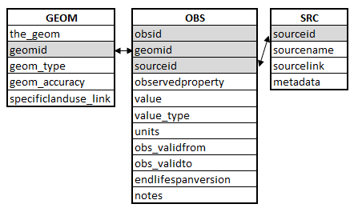

Figure 1. Structure of the data model used for harmonizing the EMODnet human activities datasets into the single European marine footprint dataset.

The “GEOM” table includes the spatial geometries reflecting either the location of human activities or the statistical spatial references for which activity information is assigned. Each geometrical feature has an unique identifier included in the “geomid” field which is the primary key that will be linked to the activity attributes to be included in the “OBS” table. The fields descriptions are described in table 1.
Table 1. Fields and descriptions of table GEOM.
Field name | Description | Type | Voidable
the_geom | Includes the geometry object in the spatial layer (point, polygon or line) | geometry | No
geomid | unique identifier of geometry | ID | No
geom_type | POINT, POLYGON, POLYLINES | codelist | No
geom_accuracy | Includes information of expected spatial accuracy (exact/ approximate/derived/schematic, etc) | string | Yes
specificlanduse_link | Link to controlled vocabulary term from HILUCS extended. | string | Yes

The “OBS” table includes the alphanumerical information, or “observations” associated to each geometry. The linkage between geometries and attributes are made though the “geomid” identifier, where 1 geometry links to n observations. The included fields are described in table 2.

Table 2. Fields and descriptions of table OBS.
Field name | Description | Type | Voidable
obsid | Unique identifier of observation | Unique ID | No
geomid | Unique identifier of geometry linked to observation | ID | No
sourceid | Unique identifier of data source linked to observation | ID | No
emodnet_layername | Original layer name in EMODNET Human activities WFS Server | Text | No
observedproperty | Observed property or parameter name (as used in EMODNET layers field names; not mapped with codelists) | Text | No
value | Value associated with Observedproperty | String | No
value_type | Type of value (string/numeric/codelist (if applicable)) | String | No
units | Units attributed to value
obs_validfrom | Initial time linked to the observedproperty/value | Date | Yes
obs_validto | Final time linked to the observedproperty/value | Date | Yes
endlifespanversion | Date of last record update | Date | No
notes | Any comment included in original EMODnet layer records | Text | Yes

The “SRC” table includes the information on the original sources of the data gathered in the EMODnet layers when available. The included fields are described in table 3.

Table 3. Fields and descriptions of table SRC.
Field name | Description | Type | Voidable
sourceid | Unique identifier of data source linked to observation | ID | No
sourcename | Data source name | Text | No
sourcelink | Link to data source | URL | Yes
metadata | Link to metadata | URL | Yes

  - Data processing
The selected EMODnet layers were examined to map the information from their original structure onto the MUD structure. The fields containing the information required by the MUD were identified, renamed and in some cases their values, modified and reformatted (i.e. years to Dates). The field mapping for each of the harmonised datasets is presented in ANNEX I. In the following sections information on the harmonisation processes performed per table and field are detailed. The results obtained and the gaps identified are also provided.

    - GEOM table fields
      - the_geom
This field includes the unique geometry objects found in emodnet layers. The multiple attributes associated to a single geometry are included in OBS table. To link geometries with attributes a “1:n” relationship has to be created between the GEOM and the OBS tables, using the “geomid” field as linkage (see section on tables relationships)
The geometries have not been modified from the original emodnet layers except for the case of the ICES statistical areas layers. (see “geom_type” section).
      - geomid
“geomid” contains unique identifiers for each spatial feature gathered in the GEOM table. Original layers were analysed to find fields with geometries identification information (i.e id, codes, etc) and check them for completeness (no gaps), uniqueness (no duplicities) and preferably international standard codes.
For layers using official unique spatial features identifiers, these were retained in the geomid field. This is the case for the ICES fisheries statistics (“f_code”, “stat_rc”), the fish sales layer (“loc_code_eumof”), the ports traffic statistical layers (“port_id”), the lighthouses (“arlhs_number”), the bathing waters (“bwid”), the wastewater treatment plants (“uwwcode”) and the wastewater disposal points (“dcpcode”).
In most of the remaining layers “Id” or “code” fields didn’t fit the above requirements and new unique geometry identifiers were generated with the following coding criteria.
[“EUMUD_GEOM_” & emodnet_layername & counter ()]
(e.g. EUMUD_GEOM_shomcables_1, EUMUD _GEOM_shomcables_2, …).

Even though, the meaningful “code”/”id” fields in original layers were not discarded but added in the OBS table as an “observedproperty” (see fieldmap in ANNEX I).
      - geom_accuracy
Information on the accuracy of the geometries with respect to the activity footprint was included In 12 of the 63 of the harmonized layers was found (see table 4). This information was assigned to the geom_accuracy field with no modification, although different coding terms are used.

Table 4. Layers with information on geometry accuracy and codes used.
Emodnet layername | Field containig information mapped to geom_accuracy | Codes used
aggregates | posinfo | Estimated, Estimated polygon centroid of dredging area, Original, Polygon centroid of dredging area, Polygon centroid of extraction area
desalination | accuracy | ACCURATE, ESTIMATED
dredging | position_i | Dredging area centroid, dredging line midpoint, Estimated, Original
finfish | point_info | Original, Polygon centroid
freshwater | point_info | Original, Polygon centroid
macroalgae | pos_info | Confirmed, Estimated
microalgae | pos_info | Confirmed, Estimated
oenergy | posinfo | Estimated, Original
oenergytests | posinfo | Estimated, Original
shellfish | position_info | Original, Polygon centroid
shellfishlics | polygon_in | Original, Lines to Polygons
spirulina | pos_info | Confirmed, Estimated

      - geom_type
The geometry types were automatically calculated from the geometry features objects (the_geom). The geometry types found across all layers included POINTS, MULTISTRINGS, POLYGONS, MULTIPOLYGONS, and MULTISURFACE.
The “fao_areas” layer from which are derived the geometries included in the ICES fishing effort and catches layers at different hierarchical level (areas, subdareas, divisions, subdivisions, units, subunits, etc) includes complex geometries of GEOMETRYCOLLECTION type that can entail difficulties for visualization and spatial analysis in some GIS clients. Therefore, this layer was substituted by a new file version with SINGLEPART POLYGONS and low-resolution coastline in order to improve the load and visualization speed. The new version is a downloadable geopackage file named “FAO_AREAS_SINGLEPART_ERASED_COASTLINE_LOWRES.gpkg” . This file is the result of postprocessing of the layers served in the FAO WFS Service (https://www.fao.org/fishery/geoserver/wfs?request=GetCapabilities).

      - Specificlanduse_link
The “specificlanduse_link” field contains the link to a controlled vocabulary classifying marine uses or marine human activities. The HILUCS_extended vocabulary has been retained to be used, as this vocabulary extends the INSPIRE Land use register to include maritime and coastal uses and is also used in Marine spatial planning datasets.
As no matching term was found for “Freshwater aquaculture”, and “dredging” in HILUCS extended, terms from the Statistical Classification of Economic Activities in the European Community Rev._2.1. (NACE_2.1) were assigned. For “lighthouses”, the general HilucsExt/4_1_4_WaterTransport was assigned even if this layer is considered in Emodnet as a cultural asset information layer.
The terms assigned to “specificlanduse_link” for each layer are listed in ANNEX I and include one of the following list:
- HilucsExt/1_3_3_OtherMiningAndQuarrying
- HilucsExt/1_4_1_1_FinfishAquaculture.html
- HilucsExt/1_4_1_2_Molluscs%20Aquaculture.html
- HilucsExt/1_4_1_3_SeaweedAquaculture.html
- HilucsExt/1_4_2_ProfessionalFishing.html
- HilucsExt/2_4_1_NuclearBasedEnergyProduction
- HilucsExt/2_4_2_FossilFuelBasedEnergyProduction
- HilucsExt/2_4_4_1_RenewableEnergyProductionWind.html
- HilucsExt/2_4_4_RenewableEnergyProduction.html
- HilucsExt/2_5_2_Desalation.html
- HilucsExt/3_4_6_2_Beaches.html
- HilucsExt/3_4_7_2_Wreck.html
- HilucsExt/4_1_4_1_Harbours.html
- HilucsExt/4_1_4_WaterTransport
- HilucsExt/4_3_1_ElectricityGasAndThermalPowerDistributionServices.html
- HilucsExt/4_3_3_1_SolidWasteTreatment
- HilucsExt/4_3_3_2_WaterWasteTreatment.html
- HilucsExt/4_3_3_5_MarineWasteDumping.html
- HilucsExt/4_3_5_1_SubmarineCablePower.html
- HilucsExt/4_3_5_2_SubmarineCableTelecom.html
- HilucsExt/6_8_MilitarArea.html
- nace2.1/0322 [Freshwater aquaculture]
- nace2.1/42.91[ Construction of water projects]

This information can be used to define and implement a standard style associated to these terms (see section for next steps).

    - OBS table fields.
      - obsid
“obsid” contain unique identifiers for each observation. The values of “obsid” are taken from the “gml_id” codes in the original emodnet layers.
Each record in the original layer (equivalent to an observation) has several attribute fields (NF) that have been pivoted to accommodate to “observedproperty/value/unit” structure in EU-MUD (see section on observedproperties/values below). Therefore each observation from the original emodnet layers will have NF records in OBS. The new records belonging to the same observation are identified by their same“obsid” value.
      - geomid and sourceid
“geomid” and “sourceid” are the unique identifiers of geometric features and sources, previously assigned in the GEOM and SRC tables respectively. Their presence in the OBS table is intended to establish relationships between the three tables in client GIS applications such as ARCGIS, QGIS, etc. (see section on relationships below).

      - observedproperty, value, value_type and units.
To accommodate the wide variety of attributes from the various emodnet original layers in EU-MUD, the fields with activity attributes have been pivoted and inserted in a “observedproperty/value/unit” common structure: The original field name has been included in the new “observedproperty” field, without any modification, and the corresponding value is included the EU-MUD value field. The obsid will be duplicated for each new record in the OBS table to keep traceability of different records belonging to the same observation. A visual example illustrating this process is provided in figure 2.
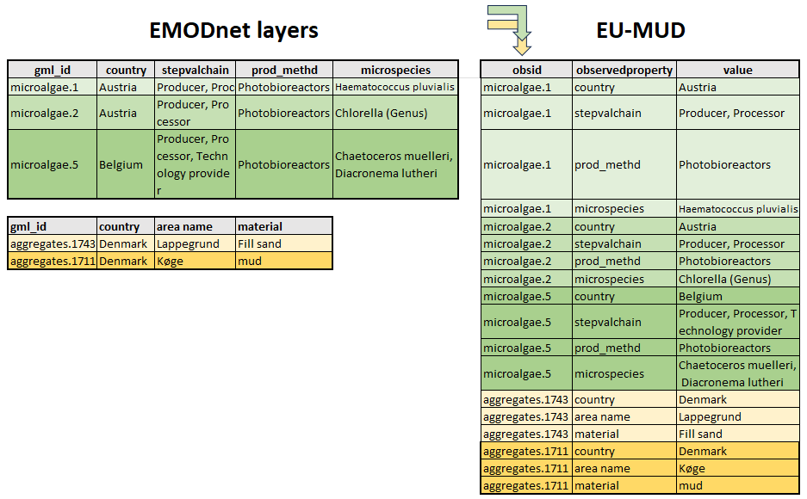
Figure 2. Example to illustrate the result from pivoting the field attributes of two emodnet layers into the single EU-MUD OBS table. The color codes of the records help identify the new position of the information in the new EU-MUD structure.

The units associated to these values should be included in the “units” field. However, as in the original EMODnet layers, units were included either in the field name or not provided, this field remains empty in the EU-MUD’s first version.
In addition, as different observedproperties can hold values of different data_types (e.g. characters or numeric), a “value_type” field has been created to hold this information and facilitate future analysis or aggregations. In this first version only character and numeric data_types have been included.
Some fields were excluded because considered redundant or easily derived with spatial analysis (see Annex I).

      - “obs_validfrom” and “obs_validto”
These fields contain information about the temporal validity of the observation: If the observation is intended to describe the installation of an infrastructure, these fields may contain the period from the installation of the infrastructure until its removal. If the observation describes a temporal activity (i.e. dredging operations), these fields will include the initial and final dates of the operation. However if the observation relates to an temporally aggregated estimation of the activity (i.e. yearly statistics), the initial and final date will correspond to the initial and ending dates of the year.
The fields from original layers that have been identified providing this information and have been added in “obs_validfrom” and/or “obs_validto” fields are included in the field map provided in ANNEX I.
In many cases these values are not provided in date format, but as strings, years or “yearmonth”. In these cases the values have been converted to date format. In cases with only year data provided, the 01-01-YYYY has been retained for “obs_validfrom”, and 31-12-YYYY for “obs_validto”. The same approach has been used for “yearmonth” values.

      - endlifespanversion
This field contains information about the last time the observation was updated: For a newly created record, it contains the creation date. If the record has been revised or modified, it will contain the revision or modification date. This information provides the user with useful information about the age of the data in the dataset.
Only the following 12 of the 62 emodnet layers selected for EU-MUD are providing this information: aggregates, aggregateareas, dredging, activelicenses, oenergy, oenergytests desalination, shellfishlics, pcablesnve, ukfibrecables, fishingbeamtrawls, and fishingsurface.

      - notes
This field includes any free comment or notes that can be relevant for the interpretation or usage of the record. This field includes the notes included in the original layers.

Table 5. Layers with added notes and field name used.
Layer | Field_name
aggregates | notes
aggregateareas | notes
dredging | notes
platforms | remarks
hydrocarbons | remarks
activelicenses | notes
oenergy | notes
oenergytests | notes
windfarms | notes
windfarmspoly | notes
desalination | technical_notes
heritageshipwrecks | reference
lighthouses | comments
pipelines | notes
pcablesrijks | comoms
rijkscables | comoms

    - SRC table Fields

      - sourceid
“sourceid” includes a unique identifier of each source found in original emodnet layers records. Its values are generated with the following coding criteria.
[“EUMUD_SRC_” & emodnet_layername & counter()]
(e.g. EUMUD_SRC_shomcables_1, EUMUD _SRC_shomcables_2, …).
      - sourcename, sourcelink and metadata
Original emodnet layers were analysed to identify the fields that provide this kind of information and add it the EU-MUD SRC table. This information is crucial to provide data traceability from the original data sources up to EMODNET and EUMUD datasets. The identified fields for each layer are included in ANNEX I.
A priori, “sourcename” should contain the text naming the data source from which the emodnet partners obtained the record information, “sourcelink” the web link from which the information was obtained (downloaded), and “metadata” the link to the metadata file associated with the original data included in the emodnet layer. However, in some cases the sourcelink include institutional webs or generic data portals.
The number of sources in each emodnet layer highly differs from one layer to another: some emodnet layers contain data only from one source whereas others gather data from multiple sources (more than one hundred in some cases). For these cases the information included in the SRC table is particularly important to keep the traceability of information flows.
Information on data sources per record are found only in 15 layers. In layers like port traffic statistics the data source is unique, and its name is mentioned in the WFS description (not in the layer itself). In other layers the description claims to gather different sources but these are not specified in the layer records (maybe these are listed in the metadata?)
In some of the layers, like cables, the sourcename can be guessed from the layer name (i.e BSH contis), but the specific sourcelink is missing.

  - EU-MUD product output

    - Data transformations
Although information from the EMODnet datasets has been transferred to EUMOD without modification wherever possible, some transformations have been required:
- Year or year-month data provided as integers or characters has been converted to a date format.
- Duplicate records have been detected and removed.
- NA or NaN values were removed and transformed into empty cells.
- Values in fields named as "country", "country_2", "country_3", "countryname", "countrynam", "country_name", have been standardised to ISO 3166 country names. The fieldnames have been inserted as observedproperties without modification.
- Complex geometries from two EMODnet layers (oenergytests and shellfishwfdareas) have been transformed to simple polygons in order to be able to merge these layers with the rest of the datasets.
- An external file for FAO areas including single part polygons has been used in replacement of the multipart polygons used in EMODnet to be able to merge these polygons in EU-MUD. This layer has been downloaded from FAO and is available in EU-MUD github repository (see publication section)

    - Format
The dataset is provided as i) a single geopackage file with a layer for OBS and SRC data and three layers for GEOM table and geometry type (poins, linestring and polygons) in EPSG: 4326.
The final file, despite the efforts for compactness (see processing section) has 3Gb size, mainly due to the large number of records in the OBS table (18.083.845). The highest number of observations are included for fish sales statistics followed by fisheries effort by rectangles, fisheries catches and port statistics.
This large number of observations significantly increases the loading time for the OBS table and the time taken to perform queries on attributes, both on QGIS or ARCGIS clients. However the visualisation and navigation of the GEOM layer is rather efficient.
A proposal for the subsequent EU-MUD versions will encompass the development of an approach to efficiently retrieve information from statistical layers in a more aggregated or compacted manner (see Next steps’ section).

    - Relationships between tables
The geopackage format is based on sqlite database and may hold structural relationships between tables. However these relationships are not yet readeable by GIS clients as QGIS or ARCGIS. Therefore no structural relationships have been added in the geopackage.
To identify the attributes from OBS table for each spatial feature in the GEOM layer in a GIS client (e.g. QGIS or ARCGIS) the user has to define these relationships in the client they are using. In QGIS, this is made within the properties of the layer join. These relationships have the function of visualising the attributes.
However, due to the high number of attributes in OBS table, these joins heavily reduce the performance of queries. A solution to this problem has yet to be incorporated into future improvements of EU-MUD (see Next steps’ section).

    - Style & HILUCS extended vocabulary classification
A specific style has been generated for EUMUD, based on the on the “specificlanduse_link” field values (see ANNEX III). This style uses thematic SVG markers for point featres, SVG line pattern for polylines and SVG fill patterns for polygon features. Polygons have also fill colors with 40% opacity. These symbols have been saved to a SLD file (EUMUD.sld).
The application of this style is an effective means of enhancing the visual interpretation of the information provided in the EU-MUD map. However, there is still scope for improvement through the completion and refinement of the HILUCS classification terms, and by refining the symbols, colour codes, and visualization scales to establish a harmonised smart style for marine applications. Close collaboration with the vocabulary maintainers at HILUCS and the Marine Spatial Planning and/or Nautical charts community, who are also developing harmonised styles for marine cartographic elements, would be highly beneficial for this task.
GeoPackage encoding can store layer styles within the database itself. This is done by saving the style information in a dedicated table named layer_styles. The style information is stored in the “styleSLD” field using the OGC Styled Layer Descriptor (SLD) format. One of the styles stored in the geopackge can be configured a default style to be renderd when the layer is loaded in a GIS client. However ARCGIS does not currently read this information, and QGIS can read it but is not able to apply the EUMUD sld to different geometry types loaded as different layers.
Fortunately, Geoserver (v. 2.19) reads and serves the EUMUD Geopackage and EUMUD.sld without any problems (WMS, WFS). (see Figure 3)
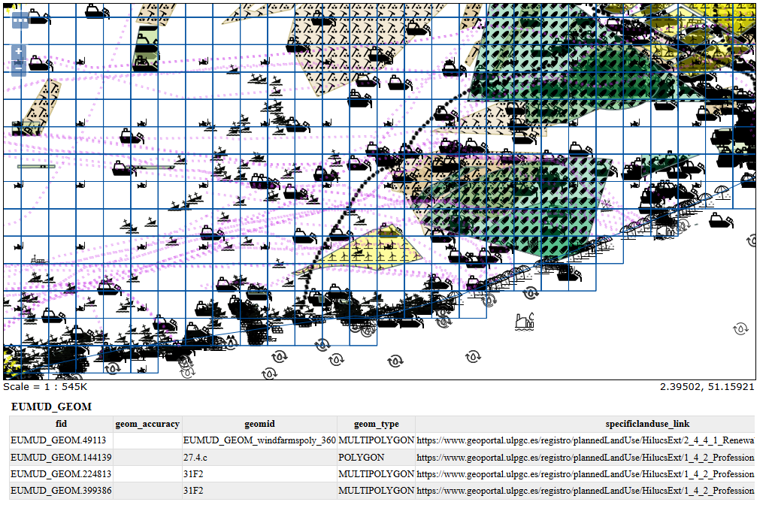
Figure 3. Example of EU-MUD GEOM layer in front of Belgian coast. The layer is served by GEOSERVER WMS, using the EUMUD sld symbology (see ANNEX III).

    - Metadata
Geopackage encoding allows the inclusion of metadata in two tables named as gpkg_metadata and gpkg_metadata_reference. However as in the case of styles, GIS clients are not yet able to read them directly.
However, in QGIS the metadata menu includes a Summary text control which reads directly from the “description” field in the gpkg_content table. All the metadata URLs associated with EMODnet layers included in the WFS GetCapabilities document, have been included in the gpkg_content table to make them findable to EU-MUD users (see Figure 4).
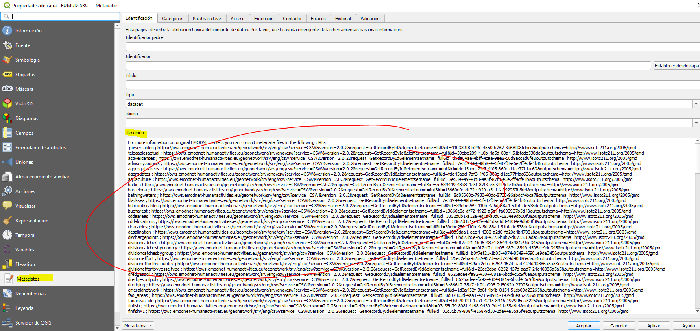
Figure 4. Inclusion of metadata URLs from EMODnet layers (WFS GetCapabilities) in the EU-MUD description field.

    - Publication
A github repository has been created to store all the generated resources in this task.
This first EU-MUD product release will be internally revised and tested by EMODnet human activities consortium and potentially published as an stand-alone product with an associated DOI.

  - Next steps for EU-MUD v 2.0

Potential improvements in original EMODnet layers:
- Harmonize field names (i.e posinfo, pos_ingo, etc),
- Harmonize values (i.e countries, NA values)
- Harmonize data formats (I.e dates),
- Adress information gaps (i.e. Sources, geometry position…),
- Harmonize geometry types (single part geometries)
- Harmonize and structure observedproperties terms (controlled vocabulary?).

Optimize EU-MUD information visualisation and query:
- Define relationships between tables in a practical way to efficiently retrieve and query OBS values from selected features in GEOM layer. Upload to POSTGRESQL/POSTGIS?.
- Compact/aggregate records in statistics layers.
- Improve and harmonize symbology. Find synergies with MSP and nautical charts cartography.
- Extend/Complete HILUCS classification terms.
- Exclude inland records (i.e desalination, freshwater aquaculture)
- Incorporate vessel density data, maybe by using standard grids like the one used in “fishing effort by rectangles” layers.

  - Potential benefits of EU-MUD product for cross-thematic analysis.

The EU-MUD product aims to facilitate the visualization and integrative analysis of marine use information in the context of multi-thematic studies. These studies may analyse different aspects like:
- Presence/Absence of different activities in different regions of interest (jurisdictions, protected areas, etc.)
- Activities interactions (synergies, competition, antagonism)
- Intersection between activities, planification of uses and regulations.
- Assessment of pressures and impacts. Risk analysis.
- Intersection between activities and ecosystem components distributions (benthic and pelagic).
- Trends of total occupancy (by different activities or by single activities).
- Seasonal distribution of activities (provided that temporal information is included).
- Activities timestamp and vulnerable times.
- Etc.

ANNEX I. MAP of Information between original EMODnet layers and EU-MUD structure

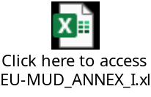
ANNEX II. List of EMODnet WFS layers not included in EU-MUD

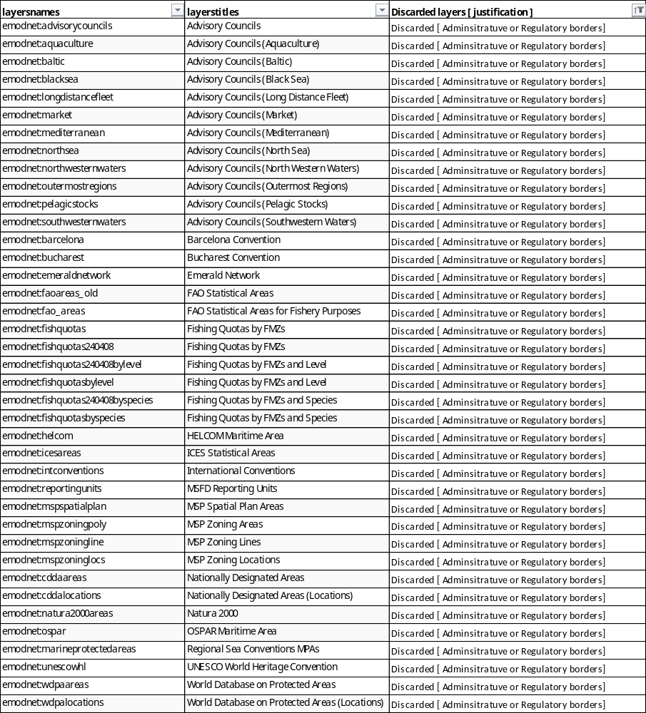

List of layers discarded for redundancy with other layers.
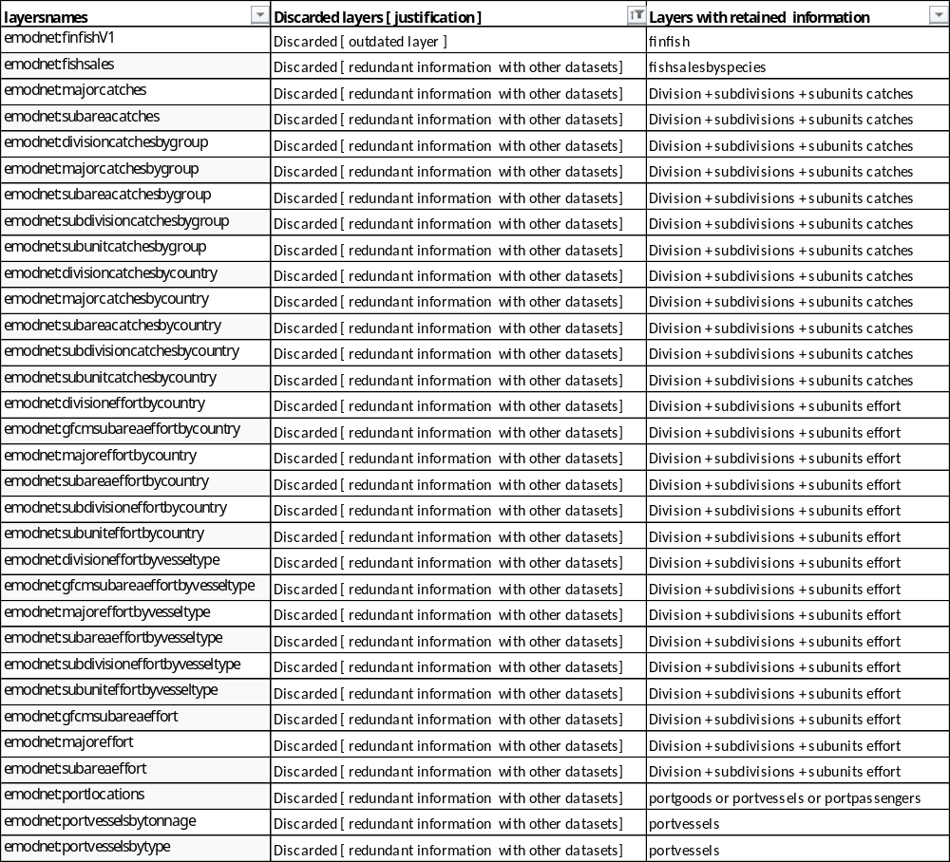

ANNEX III. EU-MUD symbology

SVG Symbols for EUMUD points
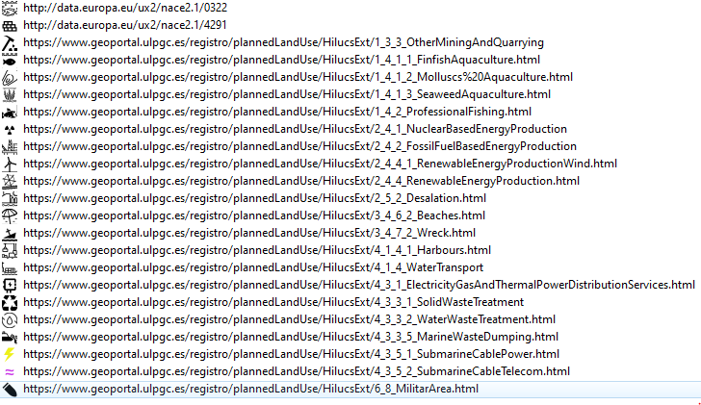
SVG Symbols for EUMUD lines (SVG pattern lines)

SVG Symbols for EUMUD polygons (SVH pattern fill + 40% transparency)
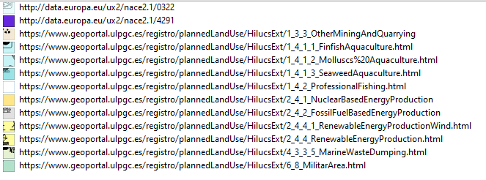

ANNEX IV. Sources used to generate EMODnet layers

EMODnet Layer | N_sources | Availability of information on data sources | New addding?
bathingwaters | 14095 | The emodnet layer harvest data from the centralised Bathing Waters Directive assessment. But this one includes the URL links to the original national/regional datasets that hold the assessment underlaying information.
dredging | 141 | The layer includes information from different data sources that are gathered and harmonised by the responsible EMODNET partner.
heritageshipwrecks | 126 | The layer includes information from different data sources that are gathered and harmonised by the responsible EMODNET partner.
oenergy | 121
aggregates | 117
aggregateareas | 51
oenergytests | 29
militaryareaspoly | 14
dredgespoilpoly | 12
dischargepoints | 6
munitions | 6
treatmentplants | 6
munitionspoly | 5
desalination | 4
dredgespoil | 4
militaryareas | 4
activelicenses | 1 | No field including original source of records.  WFS description briefly mentions the multiple data sources used. | General WFS description added as sourcename.
bshcontiscables | 1 | No field including original source of records. No info in WFS layer description, but sourcename may be guessed by layername. | Bundesamt Fur Seeschifffahrt und Hydrographie. https://www.bsh.de/EN/DATA/data_node.html
cicacables | 1 | No field including original source of records.  No info in WFS layer description. WFS description is the same as the bshcontiscables (should be revised)
rijkscables | 1 | No field including original source of records.  sourcename may be guessed by layername? RIjks?
shomcables | 1 | No field including original source of records. No info in WFS layer description, but sourcename may be guessed by layername. | SHOM (Service Hydrographic et Oceanographique)
sigcables | 1 | No field including original source of records.  sourcename may be guessed by layername? SIG?
ukfibrecables | 1 | No field including original source of records.  sourcename may be guessed by layername? UK?
pcablesbshcontis | 1 | No field including original source of records. No info in WFS layer description, but sourcename may be guessed by layername. | Bundesamt Fur Seeschifffahrt und Hydrographie. https://www.bsh.de/EN/DATA/data_node.html
pcablesnve | 1 | No field including original source of records. No info in WFS layer description, but sourcename may be guessed by layername. | NVE - Norwegian Energy Regulatory Authority
pcablesrijks | 1 | No field including original source of records.  sourcename may be guessed by layername? RIjks?
pcablesshom | 1 | No field including original source of records. No info in WFS layer description, but sourcename may be guessed by layername. | SHOM (Service Hydrographic et Oceanographique)
maltacables | 1 | No field including original source of records.  sourcename may be guessed by layername? malta?
finfish | 1 | No field including original source of records.  WFS description mentions the multiple data sources used. | General WFS description added as sourcename.
shellfish | 1 | No field including original source of records.  WFS description mentions the multiple data sources used. | General WFS description added as sourcename.
shellfishlics | 1 | No field including original source of records.  WFS description mentions the multiple data sources used. | General WFS description added as sourcename.
shellfishwfdareas | 1 | No field including original source of records.  WFS description mentions the multiple data sources used. | General WFS description added as sourcename.
FISHING catches and effort layers per FAO/ICES areas | 1 | No field including original source of records.  WFS description mentions the multiple data sources used. | General WFS description added as sourcename.
FISHING effort by ICES statistical rectangles | 1 | No field including original source of records.  WFS description mentions the multiple data sources used. | General WFS description added as sourcename.
fishsalesbyspecies | 1 | Single data source mentioned in the WFS description | General WFS description added as sourcename.
freshwater | 1 | No field including original source of records.  WFS description mentions the multiple data sources used. | General WFS description added as sourcename.
hydrocarbons | 1 | No field including original source of records. WFS description mentions the multiple data sources used. | General WFS description added as sourcename.
lighthouses | 1 | Single data source mentioned in the WFS description | General WFS description added as sourcename.
macroalgae | 1 | No field including original source of records. WFS description mentions the multiple data sources used. | General WFS description added as sourcename.
microalgae | 1 | No field including original source of records. WFS description mentions the multiple data sources used. | General WFS description added as sourcename.
spirulina | 1 | No field including original source of records. WFS description mentions the multiple data sources used. | General WFS description added as sourcename.
nuclear | 1 | No field including original source of records. WFS description mentions the multiple data sources used. | General WFS description added as sourcename.
pipelines | 1 | No field including original source of records. WFS description mentions the multiple data sources used. | General WFS description added as sourcename.
platforms | 1 | No data on original source of records. General info in WFS layer description. | General WFS description added as sourcename.
portgoods | 1 | Single data source mentioned in the WFS description | General WFS description added as sourcename.
portpassengers | 1 | Single data source mentioned in the WFS description | General WFS description added as sourcename.
portvessels | 1 | Single data source mentioned in the WFS description | General WFS description added as sourcename.
wasteatports | 1 | Single data source mentioned in the WFS description | General WFS description added as sourcename.
windfarms | 1 | No field including original source of records.  WFS description mentions the multiple data sources used. | General WFS description added as sourcename.
windfarmspoly | 1 | No field including original source of records.  WFS description mentions the multiple data sources used. | General WFS description added as sourcename.

